COMPANY INFORMATION  Prix Pharmaceutica started veterinary pharmaceutical business being an importer in the finished form in 1991 as a private partnership concern. When one hears the name Prix and its association in veterinary sector, the first hand information one will get is of quality and effectiveness, innovation to establish generics into a strong brand, a positive association for us in livestock and veterinary sector. We are sole representative of M/S EUROVET, Holland and FATRO Italy. Veterinary Medicines were imported in finished form mainly from these two companies and with the help of our own developed Marketing and Sale Team we promote / distribute them all over Pakistan. | 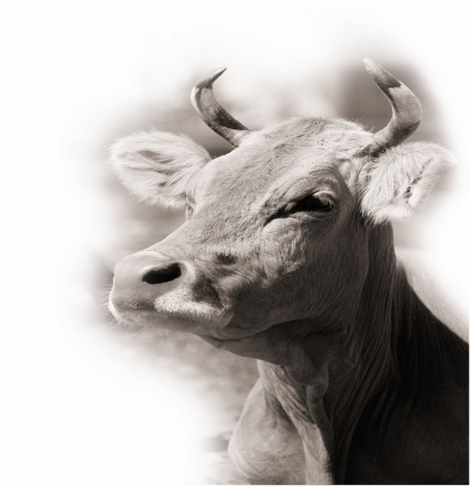

Prix strives to find solutions for animal health issues providing Antibiotics, Anthelmintic medicine for treatment and prevention of diseases and dietary supplements for beef, cattle, and milking animals to keep the Animal World moving.  Prix has served and been serving at the doorsteps of the professionals;  - Veterinarians ( Livestock / Poultry )  - Technicians ( Poultry/ Livestock & Artificial Insemination )  - Vaccinators  The company is presently selling most of its products in the market mainly through distribution network. Some sale came from the Government Institutions, like Livestock Departments of all the provinces where Prix is registered, District Councils, Pakistan Army and Pakistan Rangers. | Prix has been maintaining a strong marketing and promotional set up that earned a name for prix among its competitors cum colleagues in the Pakistan market. Our team values the brand concept and is visibly involved in the process of establishment and proliferation of Prix that can be identified by unified organizational behavior and by fundamental values. The core competency of our dedicated Team is “marketing and sales promotion.” The sales team we have developed in the last few years is our most precious asset. The Supply Chain Management System is effective and sustainable in current market environment. We have the ability to challenge the status-co. The team members are dedicated and loyal to the company. We try to fulfill their physiological and psychological needs within the limited resources that we have.

This sense of confidence is built on establishing direction; that is, articulating a credible vision for the future and its inherent opportunity for all the variables in the market. We define direction as our ability to anticipate and execute on the inherent opportunities that arose from impact of frequent changes in consumer behavior and the market.  The veterinary pharmaceutical market has come in its growth stage both for imported and locally produced medicines as sales are increasing continuously but as the import duties and infrastructure costs are increasing rapidly the profits are nose diving and with limited budgets, we always searched for ways to get the best value with our opportunities. We did not have an exceptional budget for doing any research assignment or modifying any of our products according to the market need and were not in a position to accommodate all the variables associated with our channel. We found a way. | Earlier we were selling our Products on Performance and Convenience Basis. As we were limited to only imported products but now by entering into the local manufacturing we will also penetrate through to the fragment that is more concerned with the economy part inducting with performance and convenience based on quality and effectiveness as well thus giving us the entry into another market segment that covers almost 70% of the Veterinary Medicine Sector that will put us face to face with the competitive local producers.  We will continue to pursue our promotional strategy and device new tactics to combat competition. We are also expanding our operations to the areas we were previously ignoring due to lack of resources as we can project now an apparent destiny even as the market around us changes with greater and greater incidence.  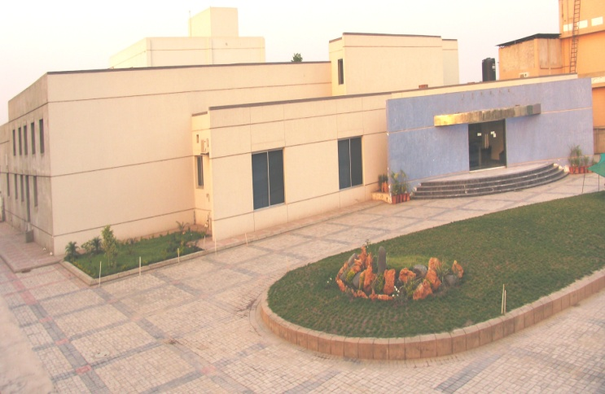    Contact Information  26-Abbot Road  Lahore-54000  Pakistan  Phone: 042-631 2582, 6316499  Fax: 042-6364196  E-mail:info@prixpharma.com
A new factory is established and revenue has started to flow inwards from mid of 2006. The manufacturing facility is located at Pharma City, industrial area Lahore on a land covering 2 acres with covered area spread over 25000 sq. ft where all the infrastructure facilities are available. At the moment Bolus, Liquid and Powder sections are operational and Commercial Batches are already in Processing. Injectable Section is under process and expected to take its full toll in later part of 2007

